

Πανεπιστήμιο Πειραιώς
Σχολή Τεχνολογιών Πληροφορικής και Τηλεπικοινωνίων
Τμήμα Ψηφιακών Συστημάτων

Επίπεδο: Προπτυχιακό/Μεταπτυχιακό Πρόγραμμα Σπουδών

Μάθημα -Τίτλος Μαθήματος: Network Security

Τίτλος -Ατομικής Άσκησης: Lab exersice 5

Επιβλέπον Καθηγητής: Χρήστος Ξενάκης

Ονοματεπώνυμο | E-mail | A.M.
Ελβις Αβντουλι | avdulielvis@gmail.com | E22001

Πειραιάς
03/12/2024

Contents
Instructions 1
Step 1: Changing Hostnames 1
Step 2: Configure PCs and Servers 2
Step 3: Configure Routers 4
Step 4: Enable OSPF 6
Test: Ping 7
Step 5: Access Control List 8
Test: ACL 9

Instructions:
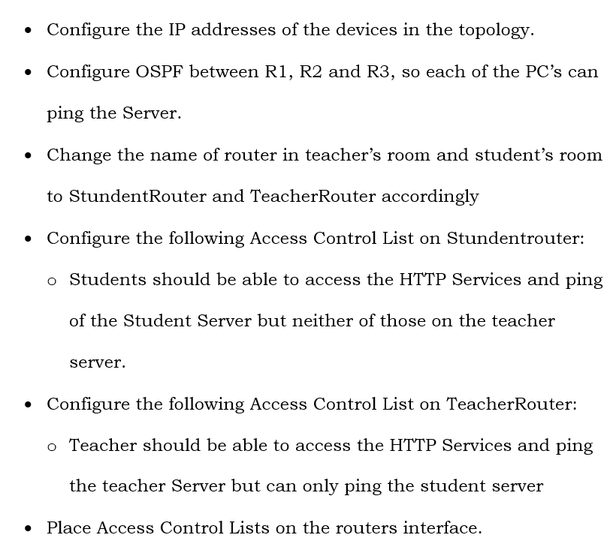

(Before step 1: All commands we must run, should be run as administrator. To do that, we must type en to enter as root and then conf t to configure terminal)

Step 1: Changing Hostnames

To change hostnames to routers, we need to use the command hostname <nameRouter>, <where nameRouter> is the name we want to give to our routers. So in R1 we must set the name “StundentRouter” and to R3 router we must set its name to “TeacherRouter”

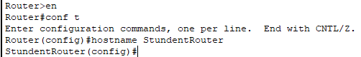
Figure 1: Changing students' router hostname

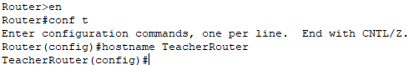
Figure 2 Changing teachers' router hostname
Step 2: Configure PCs & Servers

To configure our PCs, we must click on each device, go to “Desktop” and select “IP Configuration”. Then, we must fill the IPv4 address, Subnet mask and the Default gateway with the data that is mentioned in the topology

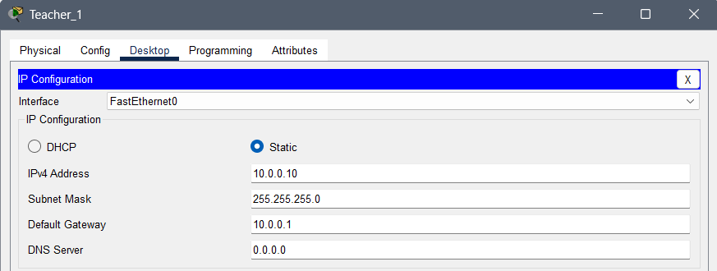
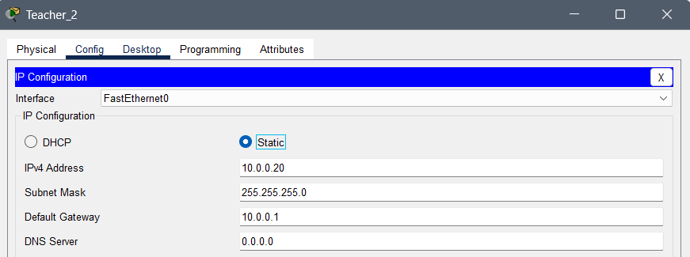
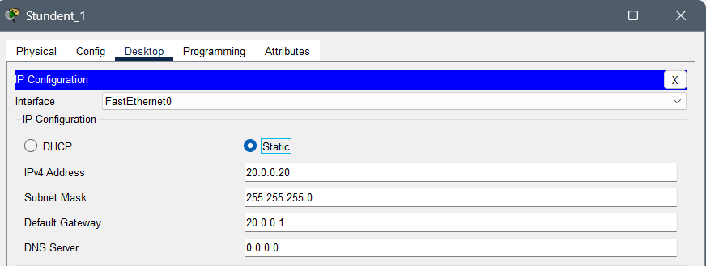
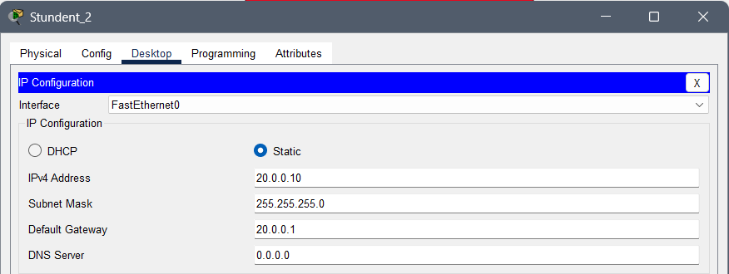

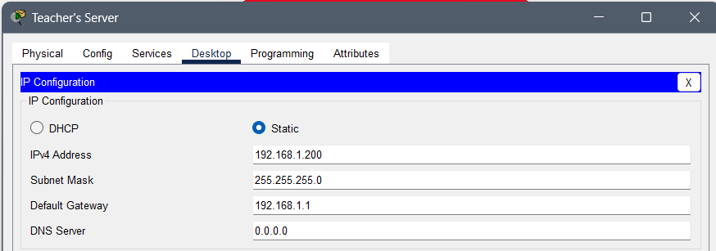

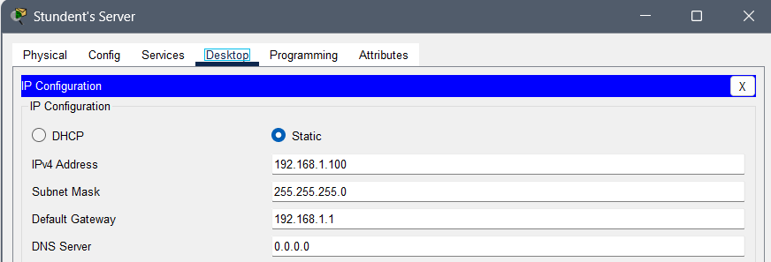

Step 3: Configure Routers

To configure routers, we must click on each router, enter as administrator, configure terminal and then, select each interface using int <interface> and type the command ip address <IP default gateway> <Subnet Mask>. Then we type do write mem to build configuration and type no shut to activate the link.

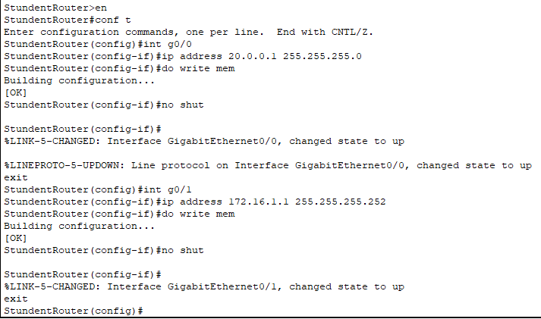
Figure 3: Configuration of Students' Router

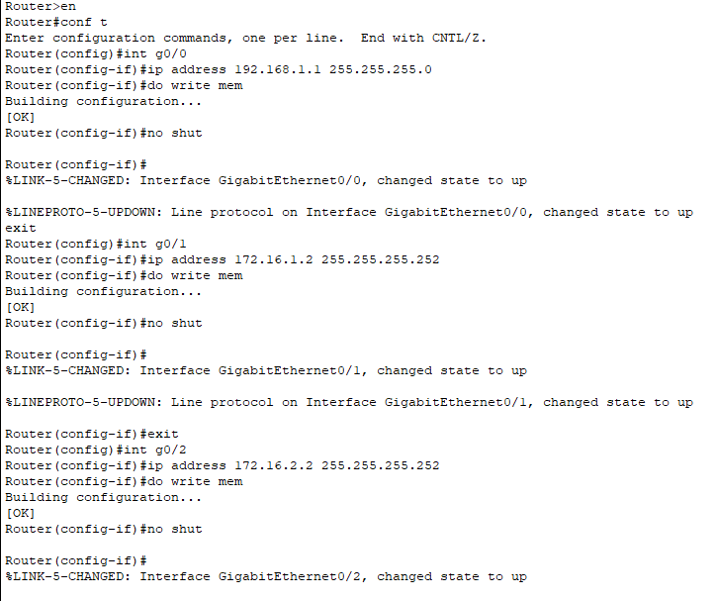
Figure 4: Configuration of Servers' Router

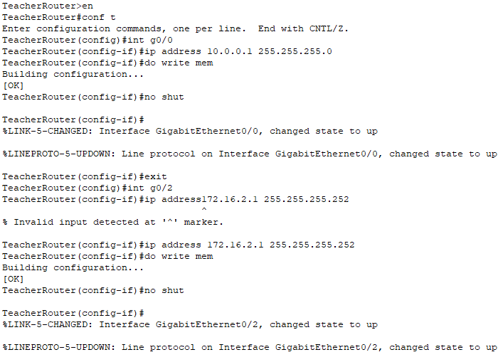
Figure 5:Configuration of Teachers' Router
Step 4: Enable OSPF

To enable OSPF we must select each router and type “router ospf 100”. Then, for each interface of the router we must type “network <IP address> <wildcard> area 0”, where wildcard it the “opposite” of subnet mask. OSPF is a link-state routing protocol that dynamically finds the best path for data packets within an IP network by sharing routing information among routers in the same autonomous system.

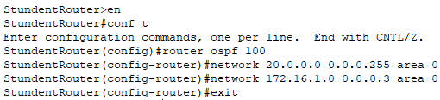

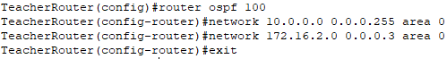

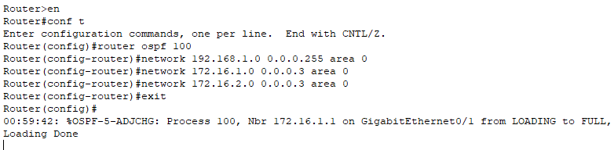

Test: Ping
To check if everything is set up correctly until now, we will try to ping from a device to another device.

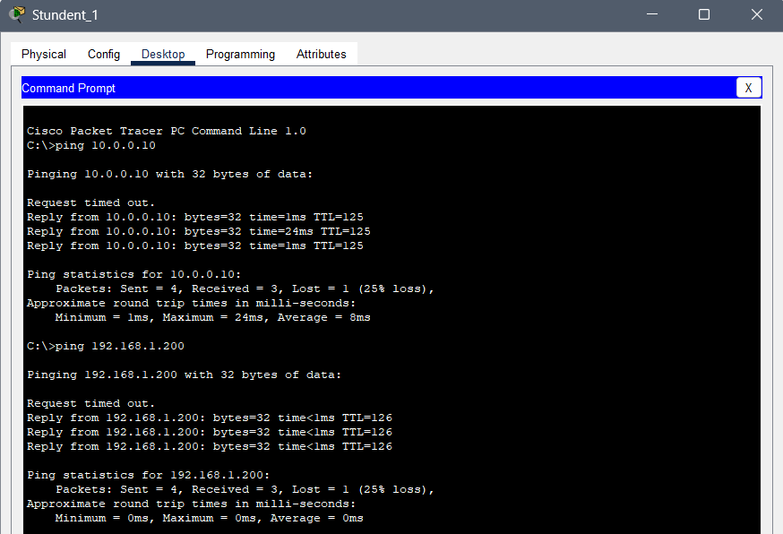

Step 5: Access Control Lists

An Access Control List (ACL) is a set of rules used to permit or deny access to network traffic based on criteria such as IP addresses, protocols, or ports. To configure an ACL, an administrator selects the router and types commands such as “ip access-list extended 101” to define a specific set of rules. Using the permit or deny commands, traffic can be allowed or blocked by specifying parameters like source and destination IP addresses, ports, and protocols. Once the rules are defined, the ACL is applied to a specific router interface in either the inbound or outbound direction using a command like ip access-group 101 in/out, effectively controlling the flow of traffic according to the organization’s requirements.

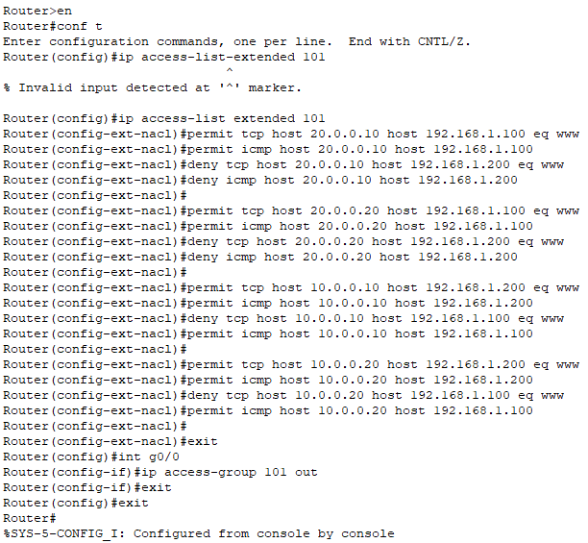

Test: ACL
Let’s try to ping both servers from a student’s PC and see what happens:
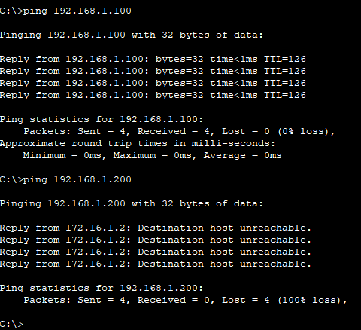
So, now students can ping only students’ server and not the teachers’ server. Correspondingly, the same happens when we try to access the http services:
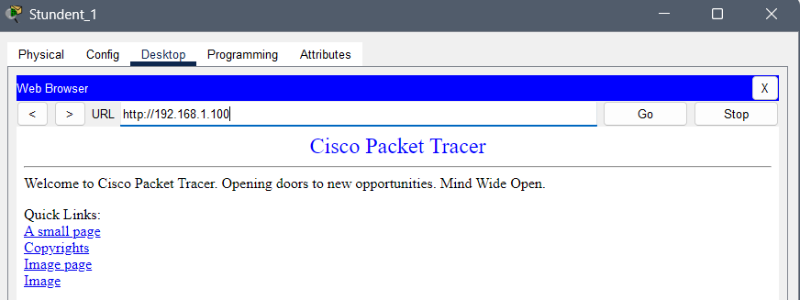
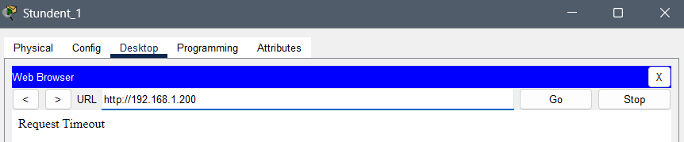
Let’s try to ping both servers from a teacher’s PC and see what happens:
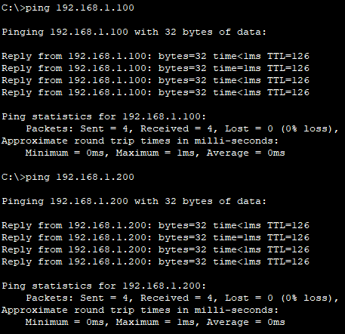
As described in the instructions, teachers can ping both servers, but they can use the HTTP services only from the teacher’s server
